Rollout and Versioning

**✅ 1. Rollout in Kubernetes**

A **rollout** refers to the **process of updating the application** to a new version in Kubernetes.

**🔹 How It Works:**

* A rollout starts when:
  + You change the **container image** version in a deployment.
  + You modify **environment variables**, configuration, labels, etc.
* Kubernetes **gradually replaces old pods** with new ones to ensure **zero downtime** (if configured properly).

🔹 **Key Rollout Commands:**

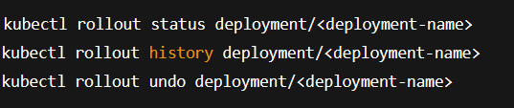

**🔹 Types of Rollouts:**

1. **Rolling Update (default):**
   * Replaces Pods incrementally.
   * Maintains service availability.
2. **Recreate:**
   * Deletes all existing pods before creating new ones.
   * Causes downtime.

**✅ 2. Versioning in Kubernetes**

Kubernetes tracks versions of deployments using ReplicaSets behind the scenes.

**🔹 Versioning Concepts:**

* Each rollout creates a new ReplicaSet.
* Old versions of ReplicaSets are kept for history and rollback.
* Use kubectl rollout history to see revision numbers.

* When a new deployment is created, say to deploy 5 replicas, it first creates a ReplicaSet automatically, which in turn creates the number of PODs required to meet the number of replicas.
* When we upgrade our application, the Kubernetes deployment object creates a new ReplicaSet under the hoods and starts deploying the containers there. At the same time taking down the PODs in the old ReplicaSet following a **Rolling Update strategy**.
* kubectl get ReplicaSet command. Here we see the old ReplicaSet with 0 PODs and the new ReplicaSet with 5 PODs  
  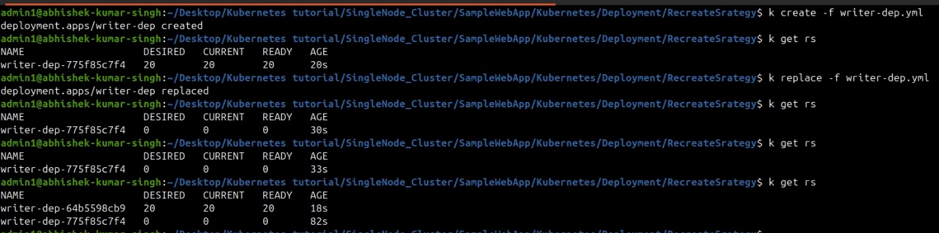  
    
  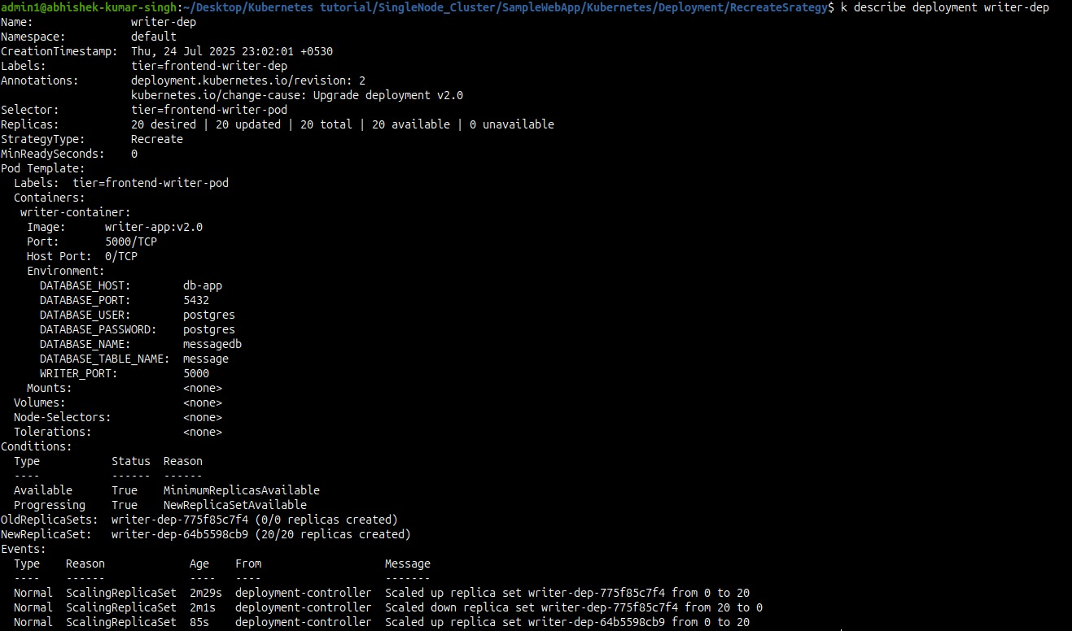
* Kubernetes keeps old ReplicaSets (v1) for rollback if needed.

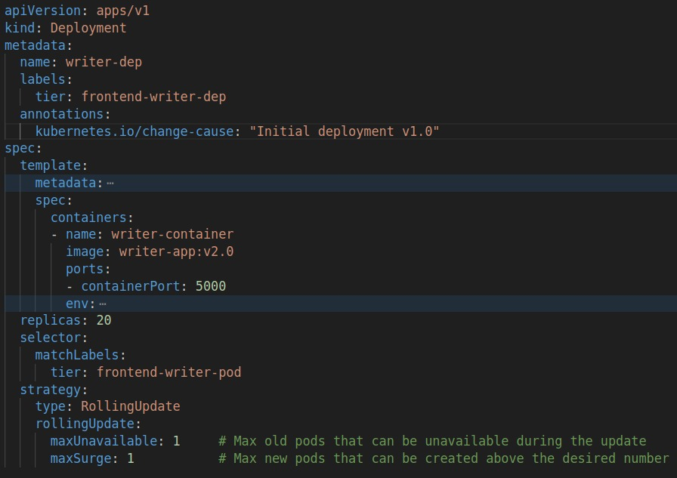

k create -f writer-dep.yml  
  
k replace -f writer-dep.yml

k rollout history deployment/writer-dep  
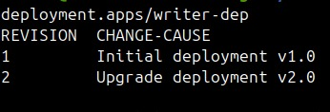

**Rollback:**

The deployment will destroy the PODs in the new ReplicaSet and bring the older ones up in the old ReplicaSet.

🔹 **Change Tracking:**

To see why a version was deployed, add a **change-cause annotation**:

Then view it with:

